**EMPLOYEE TABLE**

***CREATE TABLE SYNTAX :***

CREATE TABLE TABLE_NAME(<column-list>

[<constraint-list>]

);

CREATE TABLE Employee(

EmpNo VARCHAR2(8) CONSTRAINT EMPNONotNull not null,

EmpName VARCHAR2(20) CONSTRAINT EMPNAMENotNull not null,

Department VARCHAR2(15) CONSTRAINT DEPARTMENTNotNull not null,

Email VARCHAR2(30) CONSTRAINT EMAILNotNull not null,

Phone CHAR(8) CONSTRAINT PHONENotNull not null,

CONSTRAINT Employee_Primkey PRIMARY KEY(EMPNO)

);

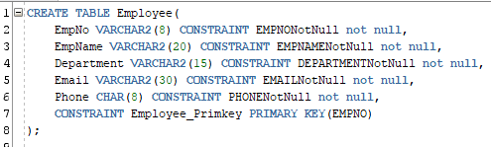

***INSERT STATEMENT :***

INSERT INTO TABLE_NAME(col_1,col_2,…col_n) VALUES (exp_1,exp_2,……exp_n);



***SELECT STATEMENT :***

SELECT * FROM TABLE_NAME;



***OUTPUT :***

